**India’s Agricultural Crop Production Analysis (1997-2021)**

**1.INTRODUCTION**

**This comprehensive project, titled India’s Agricultural Crop Production Analysis (1997-2021) with tableau, aimed to delve into the historical trends, patterns, and insights related to crop production in India over a span of two and half decades. Utilizing the advanced analytics and visualization capabilities of Tableau, the project sought to empower stakeholders, policymakers, and researchers with actionable insights for informed decision-making in the agricultural sector.**

**1.1 Overview**

**1.1.1 Objectives:**

* **Historical Analysis: Examine the historical trends in crop production from 1997 to 2021 across various states and crop types.**
* **Seasonal Variations: Analyze the impact of seasonal variations on crop production and identify patterns influencing yields.**
* **Regional disparities: Investigate regional disparities in crop production to aid in targeted policy interventions.**
* **Crop Diversity: Explore the diversity of crops grown in different regions and assess changes in crop patterns over time.**

**1.1.2 Methodology:**

* **Data Collection: Complied extensive data sets from agricultural databases government reports, and historical records covering crop production weather patterns and regional statistics.**
* **Data cleaning and integration: Processed and integrated diverse datasets to create consolidated datasets suitable for analysis in tableau.**
* **Data analysis: Utilized tableau’s advanced analytics features to derive insights, patterns, and trends in India’s agricultural crop production.**

**1.1.3Purpose**

**Using tableau for the analysis of India’s Agricultural Crop Production from 1997 to2021 can provide a comprehensive understanding of the agricultural landscape, support evidence-based decision-making and contribute to the development of effective policies for sustainable and resilient agriculture.**

**2.PROBLEM DEFINITION& DECISION THINKING**

**2.1Empaty Map**

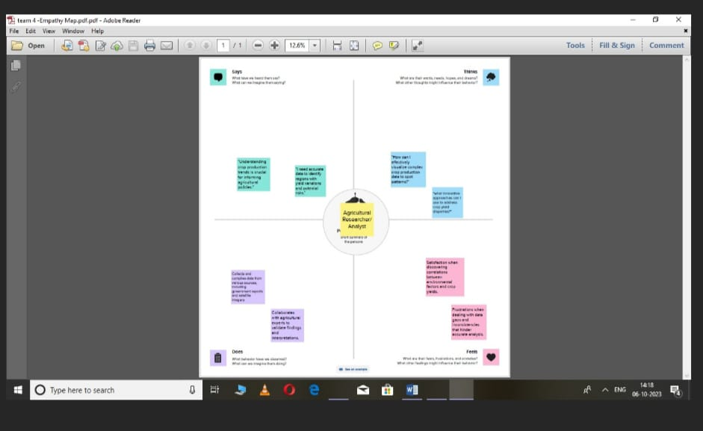

**2.2 Ideation & Brainstorming Map**

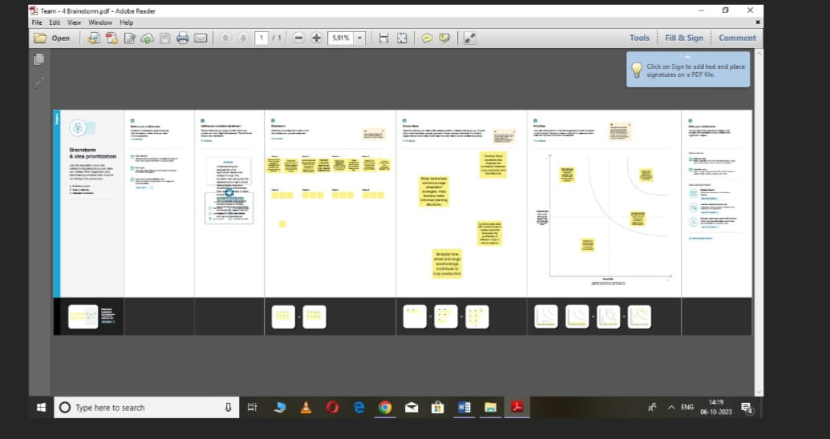

**3.RESULT**

**Data visualization involves crafting graphical depictions of data, aiming to enhance people’s comprehension and exploration of information. The primary objective is to render intricate datasets more user-friendly, intuitive, and readily interpretable. Through the strategic integration of visual elements like charts, graphs, and maps, data visualization expedites the Identification of patterns, trends, and outliers within the data, enabling individuals to swiftly grasp the insights embedded in the information.**

**3.1Visualizations**

**The diversity of visual representations achievable with a specific dataset is noteworthy. Among the myriad visualization types applicable for analyzing the performance and efficiency of banks are bar charts, line charts, heat maps, scatter plots, pie charts, maps, and more. These visual tools serve to scrutinize and evaluate various facets of banking operations, offering a versatile means to extract insights and assess different dimensions of performance.**

**Season Based Cultivation**

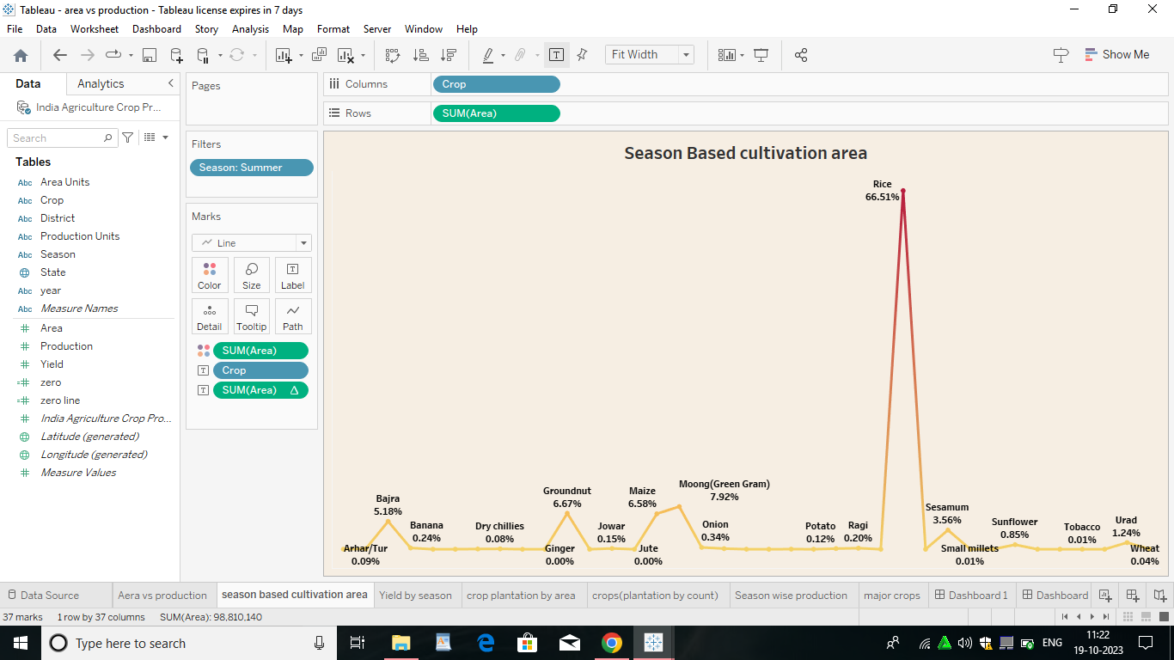

**Crop Plantation by Area**

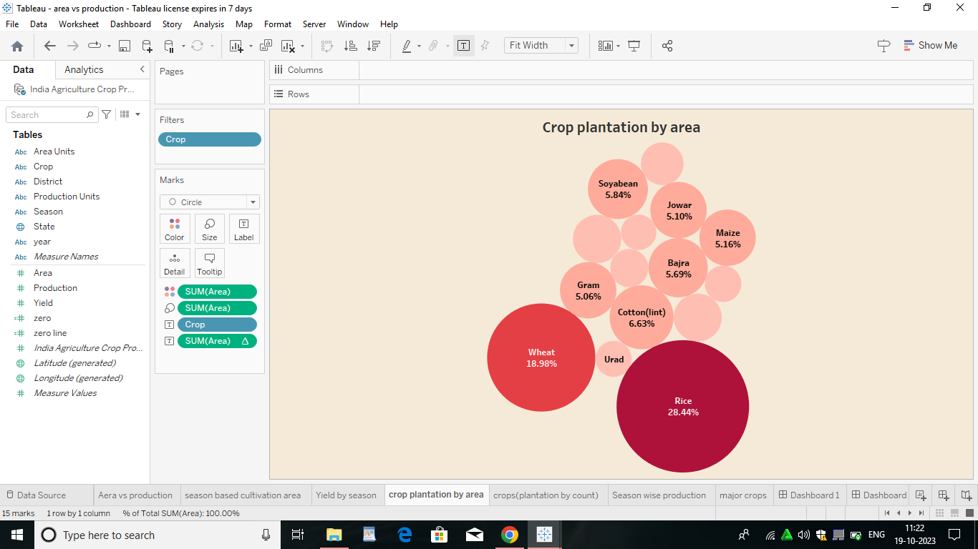

**Area Vs Production**

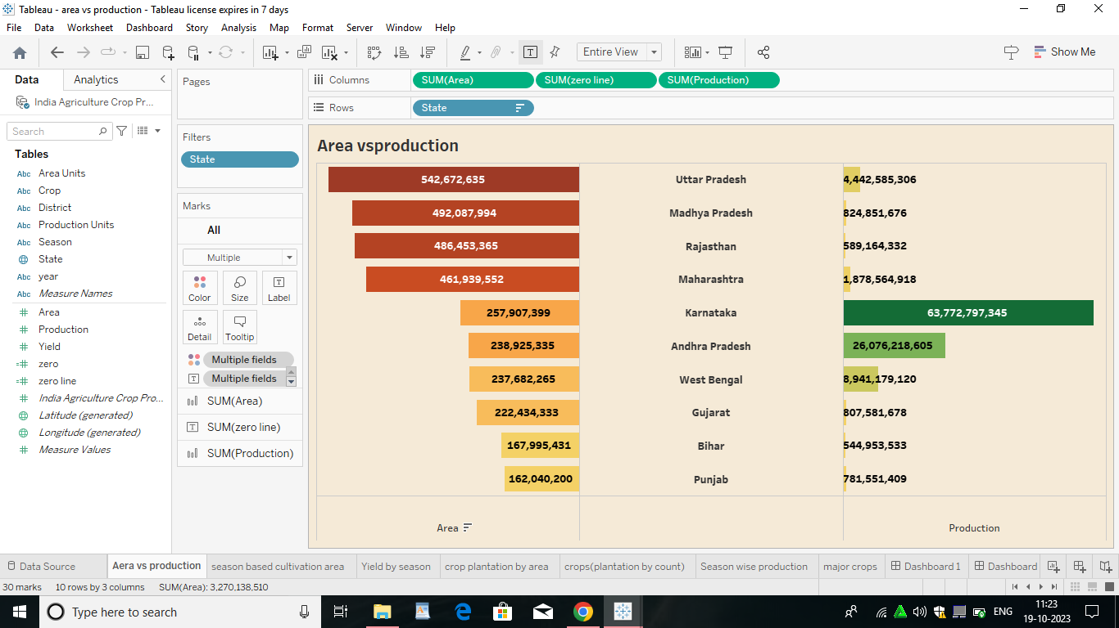

**3.2 Dashboard**

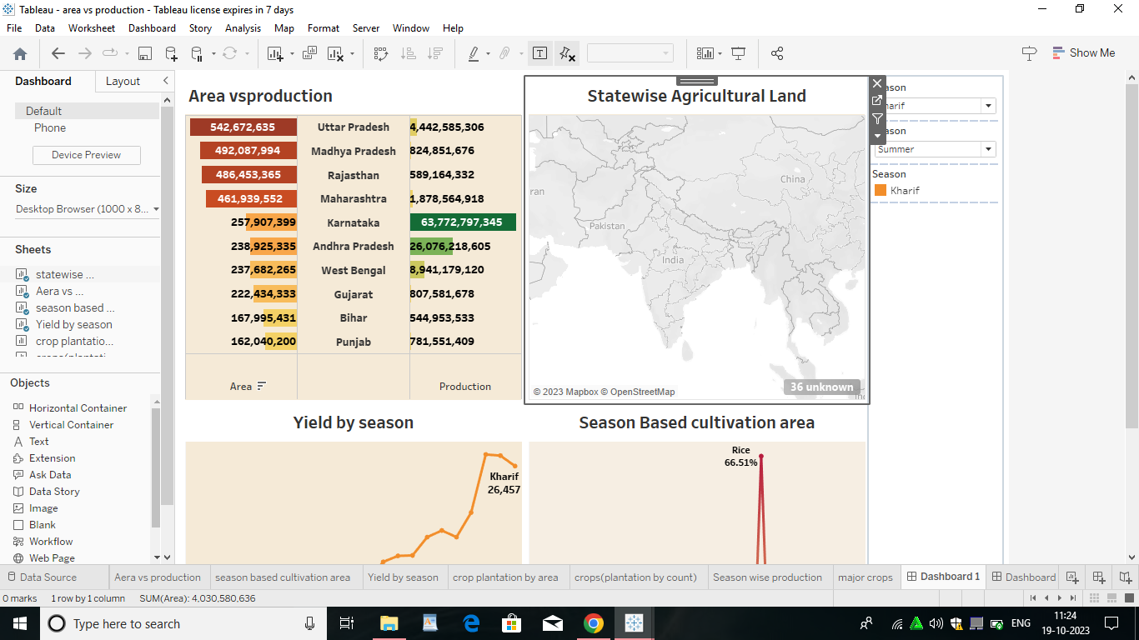

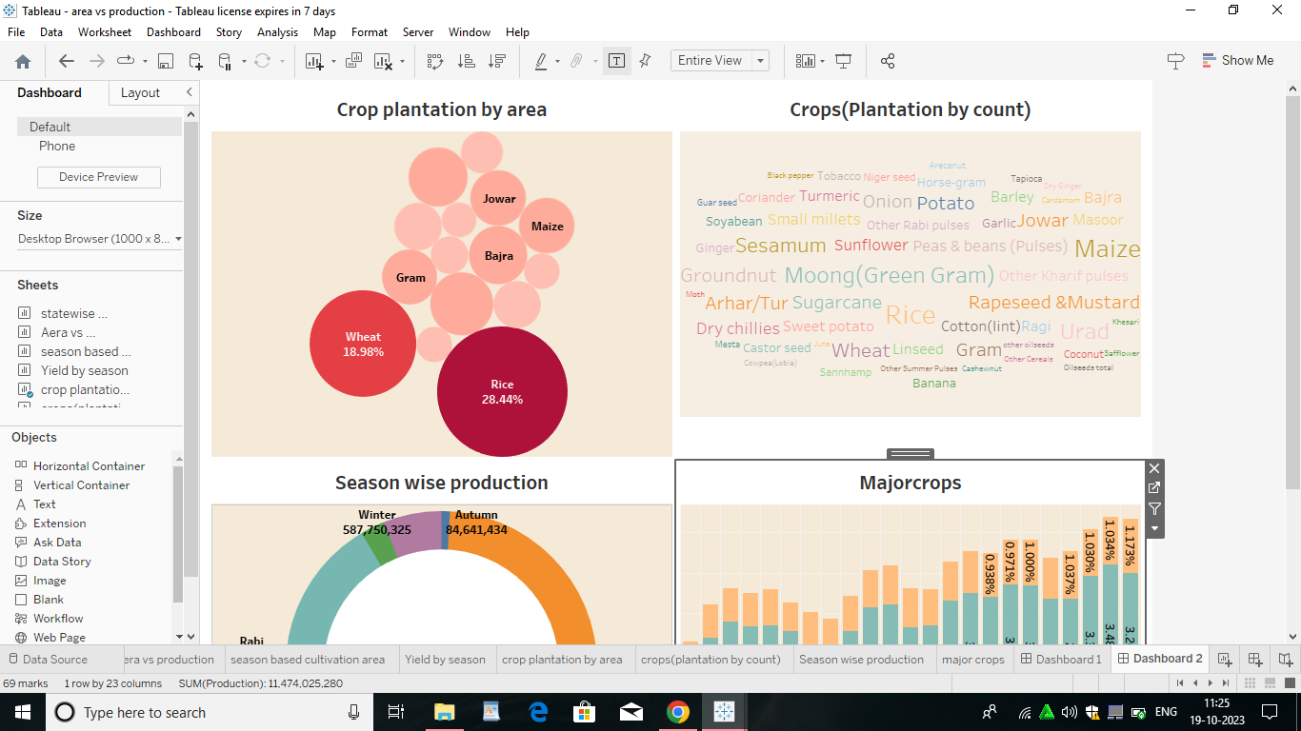

**3.3Story**

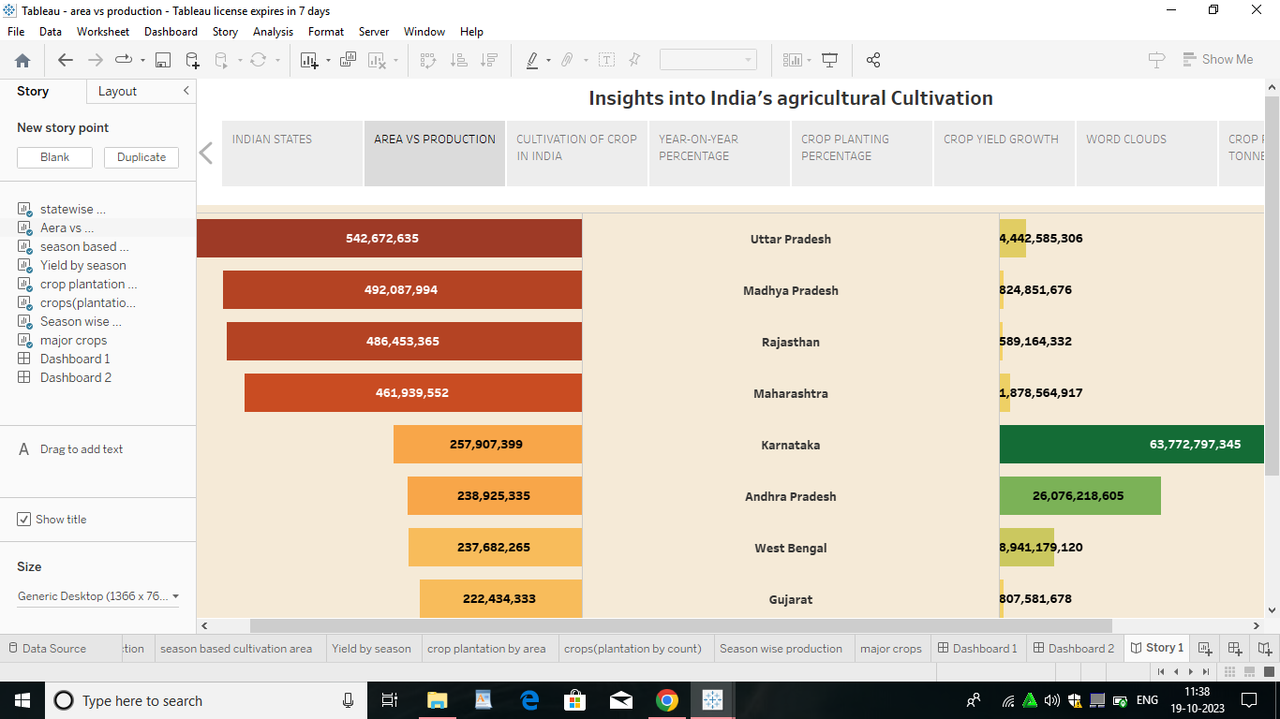

**3.4Performance Testing**

* **Amount of data rendered to Tableau: The volume of data presented in Tableau is directly influenced by the dimensions of the dataset.**
* **Utilization of data Filters:**
* **No of Calculation Fields:**
* **No of Visualizations/Graphs:**

**4.ADVANTAGES & DISADVANTAGES**

**4.1Advantages**

**Visual Clarity: Tableau’s visualization offers clear and intuitive insights, facilitating a better understanding of complex agricultural data.**

**Informed Decision-Making: Stakeholders can make informed decisions based on visualized trends, helping in strategic planning for agricultural activities.**

**Interactive Exploration: Tableau’s interactive features allow users to explore data dynamically, gaining deeper insights into crop production patterns.**

**Holisitc Overview: Dashboards provide a holistic view of crop production trends, enabling a comprehensive analysis of historical data.**

**Efficient Data Analysis: Tableau streamlines data analysis, making it efficient and accessible to stakeholders with varying levels of technical expertise.**

**4.2 Disadvantages**

**Learning Curve: Tableau has a learning curve, and users unfamiliar with the tool may require training to fully exploit its capabilities.**

**Cost of Licensing: The cost of Tableau licensing can be a constraint, especially for organizations with limited budgets.**

**Data Security Concerns: Handing sensitive agricultural data requires robust security measures to prevent unauthorized access.**

**Resource Intensive: Large datasets and complex visualizations may be resource-intensive, requiring robust computing infrastructure.**

**5.APPLICATIONS**

* **Policy Formulation**
* **Precision Farming Initiatives**
* **Market Planning for Agribusinesses**
* **Research and Development**
* **Climate-Resilient Agriculture**

**6.CONCLUSION**

**The India’s Agricultural Crop Production Analysis (1997-2021) with Tableau project successfully harnessed the power of tableau to unlock crucial insights into the dynamics of India’s agricultural sector. The findings provide a rich resource for policymakers, researchers, and stakeholders to make informed decisions aimed at improving crop productivity and reducing regional disparities and ensuring sustainable agricultural practices.**

**This project underscores the transformative impact of data analytics and visualizations in understanding complex agricultural ecosystems. By leveraging Tableau’s capabilities, stakeholders gain access to dynamic, interactive, and visually intuitive tools that facilitate a deeper understanding of historical trends and patterns, ultimately contributing to the advancement of India’s agricultural landscape.**

**7.FUTURE SCOPE**

**India’s Agricultural Crop Production Analysis (1997-2021) with tableau holds significant advantages for stakeholders but comes with considerations. The applications and future scope indicate the potential for more sophisticated and impactful use of data visualization and analytics in the agricultural sector.**

**8.APPENDIX**

**A. Source Code:**

**3.**